SOFTWARE REQUIREMENTS SPECIFICATION

**For**

**REAL ESTATE LISTINGS**

**Prepared by:-**

*Aadhavan.p*

*Adithya.A*

*Elandhevan.k*

# Introduction

## Purpose

This website is online real estate management to maintain all the property details online.It brings the real estate management online enabling real estate management participants to benefit from the internet. It acts as an interface between individuals, brokers and realtors. Our site mainly deals with property. Indealing with property two fields are mandatory. Those are owner and registration.

## Document Conventions

* + - Entire document should be justified.
    - Convention for Main title

Font face: Times New Roman Font style: Bold

Font Size: 14

* + - Convention for Sub title

Font face: Times New Roman Font style: Bold

Font Size: 12

* + - Convention for body

Font face: Times New Roman Font Size: 12

## Scope of Development Project

Real estate listings is basically updating or bring the real estate management online enabling real estate management participants to benefit from the internet. The data will be stored property in data stores, which will help in retrieval of information as well as its storage. Data is more secure. Participants can access its information and manage all the adding, updating, deleting and some of its tasks.

The project is specifically designed for the use of this online real estate site is, it provides online tool to communicate between owner and tenants. This site provide option for owner to put an ad in this site, interested user can check out the ad and they can contact the owner for rent, lease or purchase of the property.

It is very easy to search for the perfect house as the online offers are endless. All services are done free of cost. Our main concept is to give best & quick result to user.

## Definitions, Acronyms and Abbreviations

JAVA -> platform independence SQL-> Structured query Language ER-> Entity Relationship

UML -> Unified Modeling Language

IDE-> Integrated Development Environment SRS-> Software Requirement Specification

# Overall Descriptions

## Product Perspective

Use Case Diagram of Real Estate Listings

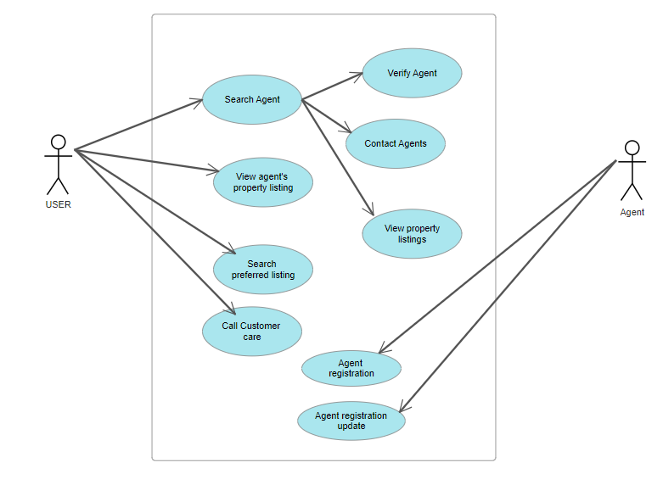

This use case diagram provides a high level overview of the interactions between different actors and the system for a real estate listings project. Keep in mind that this is a simplified example, and the actual case diagram may vary based on the specific features and requirements of your project.

## Product Function

Entity Relationship Diagram of Real Estate Listings

The Online Real Estate listings this online real estate site is ,it provides online tool to communication between owner and tenants. This site provide option for the owner to put ad in this site, interested user can check out the ad and they can contact the owner for rent, lease or purchase of the property. It is easy to search for the property house as the online offers are endless. Our site mainly deals with property. In dealing with property two fields are mandatory. Those are owner and customer registration.

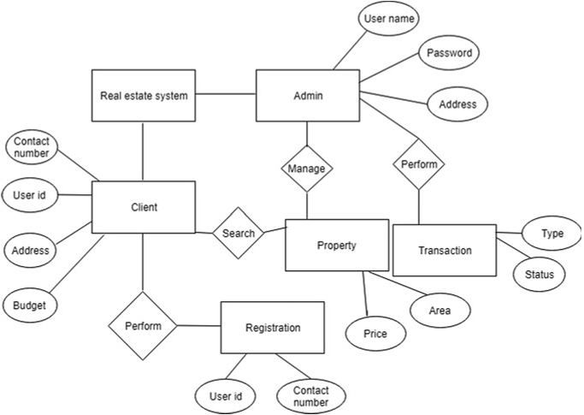

## Uses and characteristics:

A real estate listings project serves as a comprehensive platform for managing and presenting property information to potential buyers, sellers and real estate agents. The project typically involves a web application or a mobile app that facilitates the listing, viewing , and interaction with real estate properties. Here are some uses and characteristics of a real estate listings project

The features that are available to the Buyers are:-.

* + - Buyers can search for properties based on specific criteria such as location, price range, size and amenities.
    - Advanced filters to refine search result according to preference.
    - Ability to save favorite listings for future reference.
    - Notifications for updates on saved listings.
    - Buyers can inquire about specific properties directly from the listing page.
    - Track and manage their inquiries through a user dashboard.
    - Tools for comparing multiple properties side by side.
    - Personalized dashboard to manage saved searches, favorite listings and inquiries

The features that are available to the sellers are:-

* + - Create and manage property listings with detailed information.
    - Edit and update listings as needed, including price adjustments.
    - Receive and respond to inquiries from potential buyers.
    - Track and manage communications with interested parties.
    - Access to analytics on listing performance, views, and user engagement.
    - Customize a seller profile with contact information and additional details.
    - Documentation management for property transactions.

## Operating Environment

The Operating environment for a real estate listings includes the software, hardware, and network components necessary for the system to function effectively. Utilize a server side scripting language such as python, ruby or node js. Framework like django, flask , ruby on rails can be employed. Use a relational database management system(RDBMS) such as Mysql, oracle for storing property listings ,user data, and other relevant information. Use HTML, CSS, and JavaScript for creating the user interface. Employ frontend frameworks like React, Angular, or Vue.js for dynamic and responsive interfaces. Implement CI/CD pipelines for automated testing and deployment. Use tools like Jenkins, GitLab CI, or GitHub Actions for automation. Implement firewalls and security software to protect against malicious activities.Regularly update and patch software to address security vulnerabilities.

## Assumptions and Dependencies

The assumptions are:-

Users provide accurate and truthful information during the registration process.

User authentication mechanisms are secure and can be trusted.

Real estate agents and sellers provide accurate and up-to-date information when creating property listings.

Property details, including location and pricing, are reliable.

Users, especially real estate agents, comply with local real estate regulations and fair housing laws.

The platform adheres to privacy regulations and protects user data.

Users have reliable internet access to browse listings, submit inquiries, and interact with the platform.

The dependencies are:-

Integration with mapping services (e.g., Google Maps API) for accurate location representation.

Integration with payment gateways if transactions are facilitated on the platform.

Dependence on external services for image optimization and delivery (e.g., a Content Delivery Network or CDN).

Proper functioning and availability of the chosen relational database management system (e.g., MySQL)

## Requirement

Software Configuration:-

Linux (e.g., Ubuntu, CentOS) or Windows Server for hosting the application

Apache, Nginx, or Microsoft Internet Information Services (IIS) for serving web pages

MySQL, or Oracle for storing property listings, user data, and other relevant information.

Choose a server-side scripting language:

Example: Python (Django, Flask), Ruby (Ruby on Rails), Node.js (Express).

HTML, CSS, and JavaScript for creating the user interface.

Consider using a frontend framework like React, Angular, or Vue.js for dynamic interfaces.

Git for version control and collaborative development

Integrated Development Environment (IDE) for coding:

Example: Visual Studio Code, PyCharm,

Hardware Configuration:-

Deploy on one or more servers based on expected traffic.

Consider load balancing for distributing incoming traffic.

Dedicated server or cloud-based service to host the relational database management system.

Adequate storage space for property images, user data, and other media.

Consider scalable and redundant storage solutions.

Sufficient CPU and RAM resources based on the expected load.

Consider vertical scaling or horizontal scaling for increased capacity.

## Data Requirement

Implement validation checks for data accuracy, such as valid email formats, unique usernames, and proper date formats. Enforce referential integrity constraints between related entities to maintain data consistency.

# External Interface Requirement

## GUI

The external interface requirements for the graphical user interface (GUI) of a real estate listings project define how users interact with the system. Here are key aspects to consider for the GUI of a real estate listings project.

**1.)User** **Authentication**

**Login Page:**

User friendly login form with fields for username/email and password.

Option for "Remember Me" functionality.

Links for password recovery and account registration.

**Registration Page:**

Intuitive registration form with fields for username, email, password, and user type (Buyer, Seller, Real Estate Agent).

Captcha or other anti-bot mechanisms to enhance security.

**2.)User Dashboard**

**Personalized Dashboard:**

Centralized dashboard displaying user-specific information.

Sections for saved searches, favorite listings, and recent activities.

**Quick Action Buttons:**

Clearly visible buttons for common actions (e.g., create listing, submit inquiry, view profile).

**3.)Property listings**

**Search and Filter Options:**

Intuitive search bar with filters for location, price range, bedrooms, bathrooms, etc.

Advanced search options for specific criteria.

**Property Listing Cards:**

Clear and visually appealing property listing cards with essential details.

Thumbnail images for quick visual identification.

"View Details" buttons for each listing.

**Detailed Property Page:**

Comprehensive property details, including description, amenities, and specifications.

High-quality image gallery with a slideshow feature.

Contact information for the listing agent.

**4.)Inquiry and communication**

**Inquiry Form:**

User-friendly form for submitting inquiries.

Option to include a personalized message.

**Inbox and Notifications:**

Inbox or notifications section for managing inquiries and responses.

Real-time notifications for new inquiries and responses.

**5.)User profile:**

**Profile Information:**

Clear display of user information, including contact details and user type.

Option to edit and update profile information.

**Agent Profile:**

Additional section for real estate agents to showcase expertise, experience, and client testimonials.

# System Features

* The system features for a real estate listings project encompass functionalities that serve the needs of buyers, sellers, and real estate agents. Here are key features that can be incorporated into the project:
* Allow users to create accounts with a unique username, email, and password.
* Differentiate between buyers, sellers, and real estate agents during registration
* Provide a secure login mechanism with authentication.
* Option for social media login or OAuth for convenience.
* Allow users to create and manage profiles.
* For agents, include additional sections for expertise, contact information, and client testimonials.
* Allow multiple image uploads per property listing.
* Implement image optimization for quick loading.
* Provide a robust search bar for users to find properties based on keywords.
* Implement autocomplete for location suggestions.
* Buyers can submit inquiries for specific properties.
* Include a form with fields for the buyer's name, contact information, preferred contact method, and message.
* Agents can view and respond to client inquiries.
* Implement real-time notifications for new inquiries and responses
* Integrate with mapping services to visually represent property locations.
* Allow users to view nearby amenities and points of interest.
* Provide agents with analytics on the performance of their listings.
* Track views, inquiries, and user interactions.
* Tools for tracking the progress of transactions related to property listings.
* Documentation management for property transactions.
* Include mechanisms for users to provide feedback on listings and agents.
* Implement a review system for users to leave reviews and ratings.
* Ensure the platform is accessible and user-friendly on various devices (desktops, tablets, mobile phones).
* Provide a comprehensive help or FAQ section.
* Include user assistance features like tooltips and information icons.

# Other Non-functional Requirements

## Performance Requirement

## Performance requirements for a real estate listings project are crucial to ensure that the system operates efficiently and meets user expectations. Here are key performance requirements to consider:

* Ensure that property listings are retrieved quickly in response to user queries.
* Aim for a response time of 1-2 seconds for standard queries.
* Provide a responsive interface for submitting inquiries.
* Aim for a response time of less than 3 seconds for inquiry submission.
* Design the system to handle a scalable number of users and simultaneous inquiries.
* Implement load balancing mechanisms to distribute incoming traffic.
* Aim for high system availability, with a target uptime of 99.9% or higher.
* Implement redundancy and failover mechanisms to minimize downtime.
* Optimize database queries to minimize response times.
* Regularly review and optimize database indexes.
* Optimize property images for quick loading.
* Use a content delivery network (CDN) to efficiently deliver images to users.

## Safety Requirement

Safety requirements for a real estate listings project primarily focus on ensuring the security and privacy of users, protecting sensitive data, and preventing unauthorized access. Here are key safety requirements for the project

* Ensure that sensitive data, such as user credentials and personal information, is transmitted securely using encryption protocols (SSL/TLS).
* Implement strong password policies, including minimum length, complexity requirements, and regular password updates.
* Implement mechanisms to obtain user consent for data processing, especially regarding personal and sensitive information.
* If handling transactions, comply with Payment Card Industry Data Security Standard (PCI DSS) requirements.
* Ensure secure and encrypted connections for financial transaction.

## Security Requirement

* Passwords must be securely hashed and salted before storage.
* Implement strong password policies, including minimum length and complexity requirements.
* Provide optional MFA to enhance account security..
* Implement account lockout mechanisms after a certain number of failed login attempts to prevent brute force attacks.
* Grant users and systems the minimum level of access required to perform their tasks.
* Implement input validation to prevent common security vulnerabilities such as SQL injection and cross-site scripting (XSS).
* Authenticate API calls securely, using tokens or API keys.
* Implement rate limiting and throttling to prevent abuse
* Log security-relevant events for auditing purposes.
* Monitor and review logs regularly for suspicious activities.
* Regularly update and patch software, frameworks, and libraries to address known vulnerabilities.
* Monitor for security advisories and apply patches promptly.
* If applicable, ensure that mobile applications follow secure coding practices and are regularly tested for vulnerabilities.

## Requirement attributes

* Prioritize requirements based on their criticality and impact on the project
* Indicate the complexity level of implementing a specific requirement.
* Identify the source of the requirement to understand its origin and relevance
* Assess the potential risks associated with each requirement.
* Identify the criticality of the requirement in terms of security considerations.
* Provide links to detailed documentation or specifications associated with the requirement.

**Business Rule**

**Listing Submission:**

* **Rule:** Only registered real estate agents can submit property listings.
* **Rationale:** Ensures that only authorized and qualified professionals can add properties to the platform.

**Property Information:**

* **Rationale:** Ensures that users have comprehensive details to make informed decisions about the listed properties.

**Image Upload:**

* **Rule:** Each property listing must include a minimum of three images showcasing different areas of the property.
* **Rationale:** Enhances the visual appeal of listings and provides a more comprehensive view for potential buyers.

**User Privacy:**

* **Rule:** User contact information and personal details are kept confidential and not shared without explicit consent.
* **Rationale:** Protects user privacy and builds trust in the platform.

**Currency of Listings:**

* **Rule:** Listings older than 90 days without updates are marked as "Stale" to indicate potentially outdated information.
* **Rationale:** Encourages agents to keep listings current and relevant.

## User Requirement

* + - User requirements for a real estate listings project capture the needs, expectations, and preferences of the various user groups involved in the system. Here are key user requirements for different stakeholders in a real estate listings platform:

**Buyers:**

* + - **Search and Filters:**
    - Users should be able to search for properties based on location, price range, number of bedrooms, bathrooms, and other relevant criteria.
    - Advanced filtering options for specific features (e.g., swimming pool, garage) should be available.
    - **Property Details:**
    - Comprehensive information about each property, including detailed descriptions, high-quality images, floor plans, and virtual tours.
    - Clear indication of property status (e.g., available, under offer, sold).
    - **Saved Searches and Alerts:**
    - Ability to save favorite searches and receive notifications when new listings match their criteria.
    - Option to receive email or app notifications for price reductions or new listings.
    - **Inquiry Submission:**
    - Easy-to-use inquiry forms for expressing interest in a property.
    - Users should receive prompt responses from agents regarding their inquiries.
    - **User Account:**
    - Personalized user accounts to save favorite properties, track inquiries, and manage preferences.

**Sellers:**

* + - **Listing Submission:**
    - User-friendly interface for submitting property listings with essential details.
    - Option to upload multiple high-quality images and showcase unique features.
    - **Listing Management:**
    - Ability to edit, update, or deactivate listings as needed.
    - Real-time visibility into the status and performance of their listings.
    - **Inquiry Handling:**
    - Access to a centralized inbox for managing and responding to buyer inquiries.
    - Notifications for new inquiries and status updates on ongoing transactions.
    - **Performance Analytics:**
    - Analytics dashboard showing the performance of their listings, including views, inquiries, and conversion rates.
    - Insights into buyer demographics and preferences.
    - **User Account:**
    - Personalized user accounts for managing listings, inquiries, and account settings.
    - Easy access to support and resources for effective use of the platform.

**Real Estate Agents:**

* + - **Profile Creation:**
    - Comprehensive profiles with contact information, professional background, and client testimonials.
    - Option to showcase expertise in specific property types or locations.
    - **Listing Management:**
    - Ability to submit, edit, and manage property listings on behalf of sellers.
    - Dashboard to track the performance of their listings and respond to inquiries.
    - **Client Interaction:**
    - Access to a dedicated space for managing client interactions and inquiries.
    - Tools for tracking and managing transactions and negotiations.
    - **Communication:**
    - Efficient communication channels with buyers and sellers.
    - Integration with messaging or email systems for seamless communication.
    - **Appointment Scheduling:**
    - Tools for scheduling property viewings and appointments.
    - Calendar integration to manage appointments and availability.
    - **Mobile Access:**
    - Mobile-friendly interface for managing listings and client interactions on the go.
    - Push notifications for new inquiries and updates.

**Administrators:**

* + - **User Management:**
    - Tools for managing user accounts, roles, and permissions.
    - Access to audit logs for tracking user activities.
    - **Listing Oversight:**
    - Oversight of property listings to ensure compliance with business rules and regulations.
    - Ability to flag or remove listings that violate policies.
    - **Analytics and Reporting:**
    - Analytics dashboard for monitoring platform performance, user engagement, and popular listings.
    - Customizable reports for business intelligence and decision-making.
    - **System Configuration:**
    - Tools for configuring and customizing system settings.
    - Option to add or modify categories, property types, and other relevant parameter.

# Other Requirements

## Data and Category Requirement

These data and category requirements provide a comprehensive foundation for designing and structuring the real estate listings project. The effective organization and management of this data will contribute to a user-friendly, informative, and efficient platform for both buyers and sellers. Regular updates and maintenance of this data are essential to keep the platform relevant and competitive.

1. Top of Form

## Class Diagram

Creating a comprehensive class diagram for a real estate listings project involves identifying key entities, their attributes, and relationships within the system. Below is a simplified example of a class diagram for a real estate listings system. Please note that this is a basic representation, and in a real-world scenario, the class diagram could be more complex.

